##### **Step 1: Go to our chef-repo**

# cd/home/ubuntu/chef-repo

##### **Step 2:create a cookbook by using knife**

# cd cookbook

# chef generate cookbook httpd

**Step 3:knife does here is builds a simple structure within our cookbooks directory**

# cd chef-repo/cookbooks/httpd

# ls

**Step 4: Create a sample recipe**

# vim recipes/default.rb

package 'httpd' do

action :install

end

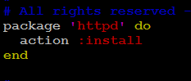

## **Step 5:Upload Cookbook to chef-server**

# knife cookbook upload httpd

**Step 6:Alternatively to check from command line on what cookbooks are uploaded on cehf-server**

# knife cookbook list

After we install the service, we probably want to adjust its current state on the node.